Instructions (delete before using this template)
Use this template for the background section of a legal due diligence report where your client (or an affiliate of your client) is acquiring 100% of the company’s shares (“target company”) from a shareholder(s) (“seller(s)”). The company’s shares are privately owned meaning the shares are not publicly listed on an exchange.
This template includes “Optional” sections in grey boxes.
Group Company/s and Affiliated Company/s
The optional sections are for the following:
(a) where the target company directly or indirectly (through another wholly owned subsidiary) owns 100% of the shares in another company (“group company”). You will need to determine (e.g. from asking your client) whether there is a group company/s; and
(b) if there is a group company/s, whether the group company/s will or will not be acquired as part of the proposed transaction. If the group company/s will not be acquired as part of the proposed transaction, these entities are generally treated as “excluded entities” and the shares in the excluded entities will need to be transferred prior to completion of the proposed transaction.
(c) where the target company directly or indirectly (through another wholly owned subsidiary) owns less than 100% of the shares in a company and more than a minimum threshold (generally called an “affiliated company”), whether the target company’s direct or indirect interest in the “affiliated company” will be acquired as part of the proposed transaction.
The “Company Group” refers to a group company/s and the company's interest in an affiliated company/s, as shown in the blue outline in the diagram below.
Delete the optional sections described above if they are not relevant to the target company. If you delete the optional sections, remember to delete any of the definitions in the glossary that are also no longer used in this template.
The diagram below is included for illustration purposes to illustrate the above terminology.
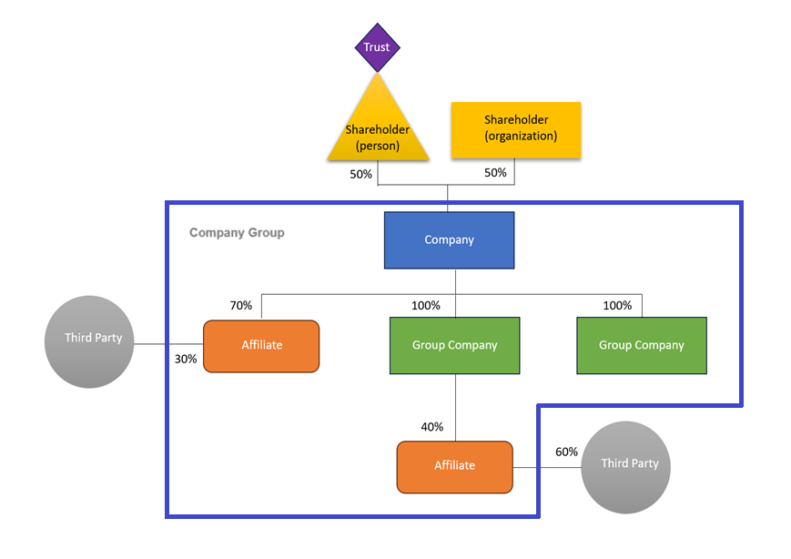

Background
Overview of Report
This Report is prepared by the Firm for [individual], a representative of the Client, who is performing the role of buyer in the Proposed Transaction. The Report details our findings of the due diligence conducted on the Company Group. This Report is intended to assist the Client in their assessment of the Proposed Transaction.
Local Law Firm
The Local Law Firm also contributed to the Report in so far as input on Local Laws were required.
Overview of Company
[Overview of Company]
Proposed Transaction
Overview
The Prospective Buyer is proposing to buy, and the Seller is proposing to sell, the Sale Shares in the Company (Target Company) in consideration for the Transaction Consideration (Proposed Transaction).
Group Company
The Company directly or indirectly (through another wholly owned subsidiary) owns all the shares in the Group Company. The Target Group Company (who is a Group Company) will be acquired as part of the Proposed Transaction.

Affiliated Company
The Company directly or indirectly (through another wholly owned subsidiary) owns less than all the shares in the Affiliated Company. The interest of the Company Group in the Target Affiliated Company will be acquired as part of the Proposed Transaction.

Company Group
The Company Group refers to the Group Company and the Company's interest in the Affiliated Company.

Corporate Restructuring
The Excluded Entities do not form part of the Proposed Transaction.

Legal risk indicators
Throughout the Report, the following indicators are used to allocate a level of risk for legal issues that we have identified during our due diligence.
These are based on the Materiality Threshold and the Proposed Transaction to assist the Client to prioritise the key findings in the Report. However, these are indicative only and should not be relied upon to the exclusion of the Client's commercial consideration of the issues raised in this Report. This Report should be read in its entirety.

Low risk | Medium risk | High risk
For noting only, low value legal risk or the issue can be addressed as part of the transaction documents. | Should be considered in your evaluation of the Proposed Transaction or should be addressed in the transaction documents if appropriate. | High value legal risk or should be addressed as a priority before signing the transaction documents.

Scope of review
The Report is [insert report style e.g. an exceptions only report] prepared in accordance with the Scope of Work and as agreed with the Client. The due diligence process concluded on the Review Date. The Firm reviewed the Review Materials in accordance with the Scope of Work. The main goal was to identify potential legal risks and liabilities which could potentially affect the value or structure of the Proposed Transaction.
Outstanding Requests for Information
This Report incorporates responses to the RFIs provided to the Firm prior to the Review Date. If there are outstanding RFIs which have not been answered as at the Review Date, the responses to which (including additional documents disclosed in the Data Room in response to the RFIs) do not form part of the Review Materials. The responses may have a material impact on the findings in this Report.
Glossary
Capitalised terms used in this Report are defined at the end of the Report.

Glossary
Term | Definition
Affiliated Company | [Definition to be provided in actual document]
Client | [Definition to be provided in actual document]
Company | [Definition to be provided in actual document]
Company Group | The Group Company and the Company's interest in the Affiliated Company.
Data Room | [Definition to be provided in actual document]
Excluded Entities | [Definition to be provided in actual document]
Firm | [Definition to be provided in actual document]
Group Company | [Definition to be provided in actual document]
Local Law Firm | [Definition to be provided in actual document]
Local Laws | [Definition to be provided in actual document]
Materiality Threshold | [Definition to be provided in actual document]
Proposed Transaction | The transaction whereby the Prospective Buyer will acquire the Sale Shares from the Seller
Prospective Buyer | [Definition to be provided in actual document]
Report | This due diligence report
Review Date | [Definition to be provided in actual document]
Review Materials | [Definition to be provided in actual document]
RFI | Requests for Information
Sale Shares | [Definition to be provided in actual document]
Scope of Work | [Definition to be provided in actual document]
Seller | [Definition to be provided in actual document]
Target Affiliated Company | [Definition to be provided in actual document]
Target Company | [Definition to be provided in actual document]
Target Group Company | [Definition to be provided in actual document]
Transaction Consideration | [Definition to be provided in actual document]

